Members’ Feedback Corner
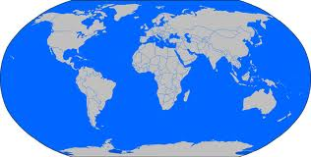
If you are looking for a PMI event to attend either in the Asia Pacific region or world-wide, we now have the major events listed on our website www.pmisydney.org under Events -> PMI Around the World.

Don’t miss the PMI NZ Conference 24 – 26 Sep. Early Bird is ending Aug 17th!
The PMI Global Congress 2012 – North America will be held 20-23 Oct in Vancouver, Canada.
For more information, go to our website ->Events -> PMI Around the World, and click on the links next to each event.
Happy Travelling
Follow us on Twitter (@PMISydney) for all latest updates on what’s happening at PMI Sydney, Australia, Asia Pacific and the world!

